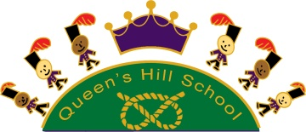

**September 2021**

**Queen’s Hill’s News**

**It's starting to feel a lot like "normal"!**

We have had a great first week back to school. Thank you all so much for your support over the last few days.

We are living in very different times now and it does feel a bit strange, but mainly in a positive way! It is lovely to see children in the corridor and having lunch together. At the moment having the whole school in the hall seems a step too far, but we have had Key Stage singing assemblies with the windows open and the classes spaced out and it has been a joy to feel like a "proper" community again.

Covid-19 remains with us, and I think that the best approach to take is that we all assume that at least one person in the school is likely to have Covid at any given time, especially as we are so large and knowing that it is out and about in the community. We won't inform you of any positive cases unless we have so many that we need to go back into bubbles as I think we'd be writing to you every day! Just to reassure you that we do let the parents/carers of our children who have extremely low immune system due to illness or treatment when there has been a positive case in their class.

The autumn term is always a difficult one illness wise, especially for Reception children who are building up their germ resilience. If in doubt we advise that your child takes a PCR test, although this is down to you as a parent/carer to decide.

We have included the current government guidance in this newsletter.

It would be really lovely to be able to welcome you into school more this year as I know many of you have missed attending reading cafes and assemblies etc. We are going to start with Show and Share assemblies, but it will only be performed to the parents/carers, the other classes will watch remotely. This gives you the chance to see your children, is the same "germ set" and we know that, if you were feeling unwell, you would not attend. We do ask that you wear a facemask if you are able to, and please adhere to social distancing inside the building. Obviously, if we have a number of cases within school, we will revert to remote assemblies for all.

Take care and keep safe,

**Penny Sheppard**

**Diary Dates**

|  |  |  |  |  |  |  |  |  |  |  |  |  |  |  |  |  |  |  |  |  |  |  |
| --- | --- | --- | --- | --- | --- | --- | --- | --- | --- | --- | --- | --- | --- | --- | --- | --- | --- | --- | --- | --- | --- | --- |
| |  |  | | --- | --- | | **Tuesday 14th September** | **Swimming for named children (Year 3)** | | **Wednesday 15th September** | **Reception children in Full Time** | | **Thursday 16th September** | **Swimming for named children (Year 6)** | | **Friday 17th September** | **9am Show and Share – Mr. Jones** | | **Friday 24th September** | **European Languages Day** | | **Friday 1st October** | **9am Show and Share – Miss. Phillips** | | **Friday 1st October** | **2.20pm Show and Share – Miss. Taylor** | | **Thursday 7th October** | **3.30pm Year 1 Café virtual (possibly in school – more information to follow)** | | **Friday 8th October** | **Harvest Festival – children only** | | October | Black History Month | | **Friday 15th October** | **‘Norfolk Welcomes’ curriculum day** | |
| **Term Dates** |

**SUMMER TERM 2022**

*Wednesday 20th April 2022 – Friday 2nd July 2022

**Half Term**

Monday 30th May 2022 – Friday 3rd June 2022

***Inset Days (Closed to Children)***

*Monday 25th July 2022*

*Additional bank holiday on 19th April 2022 in lieu of bank holiday for Queen Reign in half-term

**SPRING TERM 2022**

Tuesday 4th January 2022 – Friday 1st April 2022

**Half Term**

Monday 14th February 2022 – Friday 18th February 2022

**AUTUMN TERM 2021**

Monday 6th September 2021 – Friday 17th December 2021

**Half Term**

Friday 22nd October 2021 – Friday 29th October 2021

***Inset Days (Closed to Children)***

*2nd and 3rd September 2021, 22nd October 2021 and 9th November 2021*

**What’s going on**

Queen’s Hill Primary

**Keep Informed at:**

queenshill.norfolk.sch.uk 



**at queen’s hill?**

@QPrimary

**Ensuring we are a ready, safe and respectful school**

Our three school rules are ready, respectful and safe; the school rules are followed by all members of our school community (children, parents and families and staff). This term we are going to be focusing as a school community on routines, as we start to get back to a place of normality. Each week we will be learning a new routine to help all children become successful learners.



**In Memory of One of Our Mums**

Over the holidays, very sadly one of our parents died following a short battle with cancer. If you would like to donate to Priscilla Bacon Lodge in her memory, the link is below. If you would prefer to make a donation via the school, please put in an envelope marked "IN MEMORY" and hand in at the school office.

Kat will be remembered for her skill in all things craft- based and many of you will have seen her crocheting away whilst waiting in the queue for pick up. Our hearts go out to her family and friends in this difficult time.

<https://kathrynbrooks.muchloved.com/>

**After School Clubs**

We have an exciting range of after school activities that will be released very soon on School Money (a text will be sent out when they are live)!

After-School Club Set Your Sights, our after-school club provider (Set Your Sights) is up and running. They run from 3-6pm in our school studio. Email office@setyoursights.net or visit www.setyoursights.net to find out more about how to book.

**Outdoor Learning**

We will be learning in our new onsite outdoor classroom this term as well continuing to visit the Country Park. Please make sure your child is dressed for the weather. Wellies and waterproofs are always worth bringing as the grass can be wet in the morning.

**Inspiring Norfolk**

The topic theme for this term is “Inspiring Norfolk”, with a focus on history, geography and the community.

There are lots of ideas on the Inspiring Norfolk website which you may decide to look at as a family. Under the video are a number of challenges you can complete at home.

<https://www.inspiringnorfolk.co.uk/>

**A Great Opportunity to Contribute to The Guardian**

Are you aged between 8-14? Love nature and writing? The Guardian is on the hunt for new submissions for their Young Country Diary series!

Check out the link for more details

<https://www.theguardian.com/environment/2021/aug/27/nature-lovers-guardian-young-country-diary-writers>

Entry Deadline: Wednesday 15th September 2021



**Job Opportunity**

We are currently on the hunt for new Midday Supervisory Assistants (MSAs) to join the Queen’s Hill team on a relief basis. If you are interested please email [office@queenshill.norfolk.sch.uk](mailto:office@queenshill.norfolk.sch.uk)

MSAs work 11.30am – 1.30pm or 12pm – 1pm daily. You will need a DBS check for this role, will be required to move tables/chairs and supervise the children outside.

**Snack Time in KS2**

In Years 3, 4, 5 and 6, children are encouraged to bring a snack into school for their mid-morning break. Children have been told in our school assembly this week that the following snacks are allowed:

* **Fresh or dried fruit**
* **Vegetables**
* **Yoghurt**
* **Cheese and crackers**

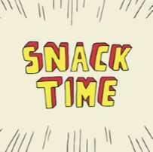

**Packed Lunches**

If your child is coming into school with a packed lunch, please make sure it doesn’t contain any solid chocolate bars (eg. Dairy milk, Freddo, Galaxy).

Items that contain a small amount of chocolate are allowed (eg. Chocolate Cookie, KitKat and Penguin Bar).

Please remember, we are a nut-free school as we have a number of staff and children with severe nut allergies.

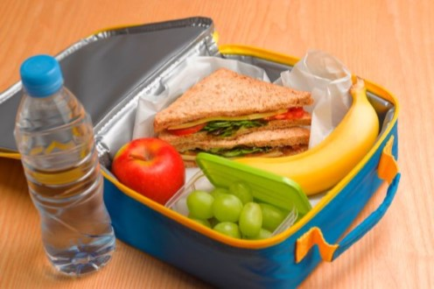

**Current Covid-19 Information and Guidelines**

A quick reminder of the government and NHS listed symptoms:

* A high temperature
* A new, continuous cough
* Loss of taste and/or smell

If you think that your child may have Covid-19, please let the office know so they can arrange home learning for your child ([office@queenshill.norfolk.sch.uk](mailto:office@queenshill.norfolk.sch.uk)).

If in doubt, try and organise a PCR test for your child if they are over the age of 5 years or seek assistance from the government website: <https://www.gov.uk/coronavirus>

**IMPORTANT REMINDER – SCHOOL CLOSED TO PUPILS (INSET DAY)**

Tuesday 9th November 2021

Staff will be accessing training remotely with a world renowned educationalist! Do check with school calendar on our website as our terms dates can differ from other schools.

This has been a longer term project and is the final part of the training focusing on improving learning outcomes for children.

