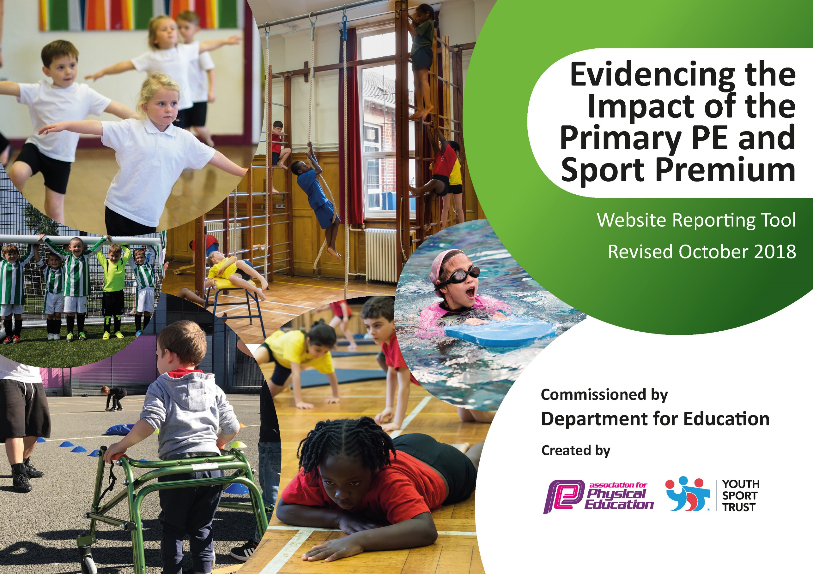
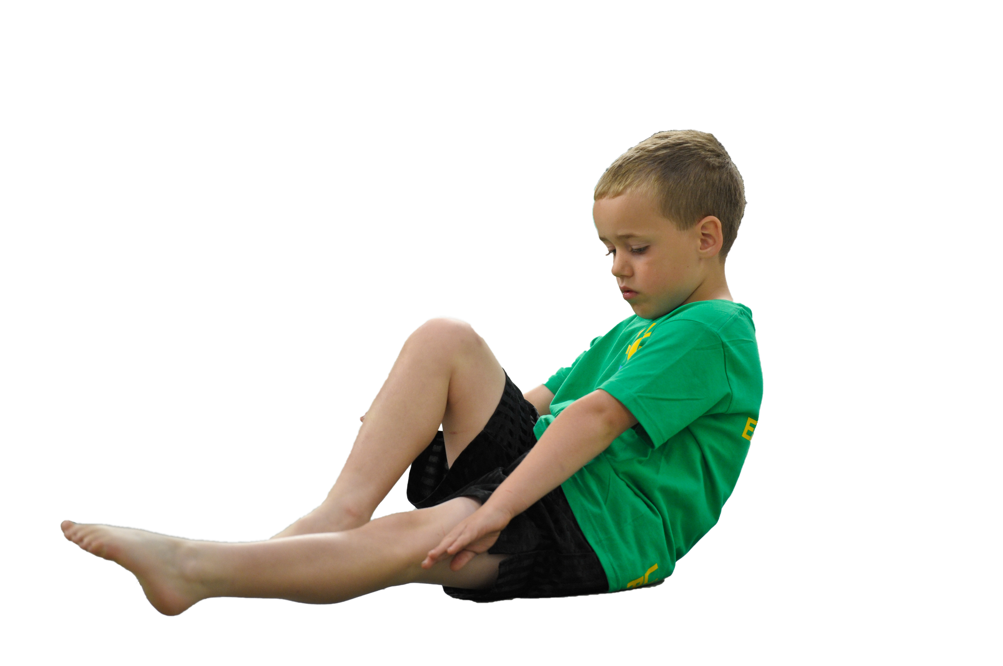
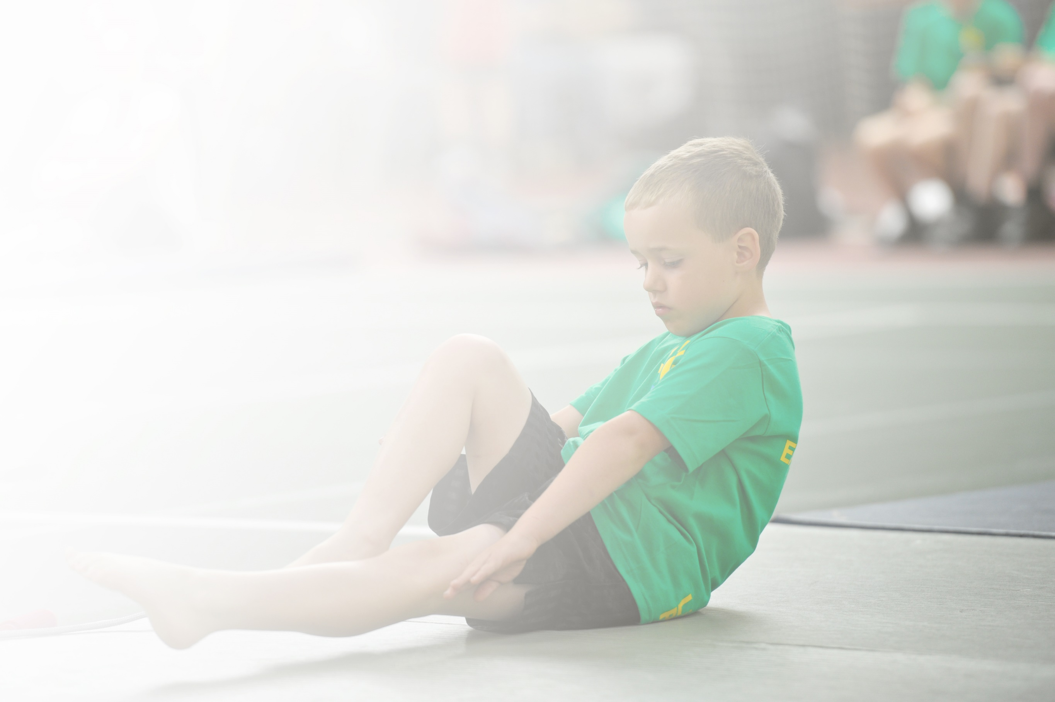
Schools must use the funding to make additional and sustainable improvements to the quality of Physical Education, Sport and Physical Activity (PESPA) they offer. This means that you should use the Primary PE and Sport Premium to:

- Develop or add to the PESPA activities that your school already offer
- Build capacity and capability within the school to ensure that improvements made now will benefit pupils joining the school in future years

Please visit gov.uk for the revised DfE guidance including the 5 key indicators across which schools should demonstrate an improvement. This document will help you to review your provision and to report
your spend. DfE encourages schools to use this template as an effective way of meeting the reporting requirements of the Primary PE and Sport Premium.

We recommend you start by reflecting on the impact of current provision and reviewing the previous
spend. Under the Ofsted Schools Inspection Framework, inspectors will assess how effectively leaders use the Primary PE and Sport Premium and measure its impact on outcomes for pupils, and how effectively governors hold them to account for this.

Schools are required to publish details of how they spend this funding as well as on the impact it has on pupils’ PE and sport participation and attainment by the end of the summer term or by 31 July 2019 at the
latest.
We recommend regularly updating the table and publishing it
on your website throughout the year, as evidence of your
ongoing review into how you are using the money to
secure maximum, sustainable impact. To see an
example of how to complete the table please
click HERE.

Support for review and reflection - considering the 5 key indicators from DfE, what development needs are a priority for your setting and your students now and why? Use the space below to reflect on previous spend, identify current need and priorities for the future.

Key achievements to date: | Areas for further improvement and baseline evidence of need:
New curriculum plan created and implemented throughout the school  A 50% increase of extra-curricular sports offered throughout the year with an increased number of children attending | Continue to monitor the confidence and delivery of PE in new staff  Ensure the fitness levels of pupils continues to rise

Meeting national curriculum requirements for swimming and water safety | Please complete all of the below:
What percentage of your current Year 6 cohort swim competently, confidently and proficiently over a distance of at least 25 metres?  N.B. Even though your children may swim in another year please report on their attainment on leaving  primary school. | %
What percentage of your current Year 6 cohort use a range of strokes effectively [for example, front crawl, backstroke and breaststroke]? | %
What percentage of your current Year 6 cohort perform safe self-rescue in different water-based situations? | %
Schools can choose to use the Primary PE and Sport Premium to provide additional provision for swimming but this must be for activity over and above the national curriculum requirements. Have you used it in this way? | Yes/No

Action Plan and Budget Tracking
Capture your intended annual spend against the 5 key indicators. Clarify the success criteria and evidence of impact that you intend to measure to evaluate for students today and for the future.

Academic Year: 2019/20 | Total fund allocated: £19,380 | Date Updated: Autumn 2019
Key indicator 1: The engagement of all pupils in regular physical activity – Chief Medical Officer guidelines recommend that primary school children undertake at least 30 minutes of physical activity a day in school |  |  |  | Percentage of total allocation:
 |  |  |  | 6%
School focus with clarity on intended impact on pupils: | Actions to achieve: | Funding allocated: | Evidence and impact: | Sustainability and suggested next steps:
An increased number of children will take part in daily physical activity and be engaged in different ways to achieve this. | Skip2BeFit workshop  Golden Mile  Koboca  Playground leadership day | £285  £400  £100  £300 | Fitness levels will increase in all year groups and more children will be taking part in daily physical activity  A rise in fitness levels will be evident through the premier education assessments  Children’s voice will be evident in our curriculum and clubs to ensure 100% increase in daily physical activity participation  More children will become active at lunchtime | Ropes purchased to have in school and parents offered to purchase. In school workshops and competitions offered.  Internal competitions offered as alternatives to continue pupils’ engagement with the daily mile.  Data used to inform planning  Trained leaders through the day will continue to deliver activities each lunch time and train further people
Key indicator 2: The profile of PESSPA being raised across the school as a tool for whole school improvement |  |  |  | Percentage of total allocation:
 |  |  |  | 31%
School focus with clarity on intended impact on pupils: | Actions to achieve: | Funding allocated: | Evidence and impact: | Sustainability and suggested next steps:
The profile of PE will be high across the school and bespoke days will support areas of need following observations.  Outdoor areas will be engaging and ready to help raise the profile of physical education, school sport and physical activity. | SSP renewal offering CPD, sporting events and coaching opportunities purchased  Power of sport assembly  Health assembly  Outdoor areas invested in to raise the profile of PESSPA. | £2850  £75  £75  £3000 | Staff confidence in PE will be raised, at least 30% of children will participate in SSP festivals/competitions the year, the school will show an awareness for the importance of PESSPA | Internal competitions and increased club opportunities to keep children engaged and prepared, staff delivering learnt content from courses  Features from the assembly continued to be talked about and evident around the school

Key indicator 3: Increased confidence, knowledge and skills of all staff in teaching PE and sport |  |  |  | Percentage of total allocation:
 |  |  |  | 4%
School focus with clarity on intended  impact on pupils: | Actions to achieve: | Funding  allocated: | Evidence and impact: | Sustainability and suggested  next steps:
Children will participate in high quality PE sessions delivered by confident teachers as a result of CPD. The new curriculum and resources implemented will support confidence, knowledge and skills. | ASA subscription  AFPE subscription  Subject Leader Mentoring  NQT course | £60  £145  Included in KI2 SSP renewal price  £525 | Resources and CPD provided through both subscriptions will be shared and used  Subject leader will be able to evidence impact and feel confident to implement changes across the school  NQTs will have raised confidence towards teaching PE and be able to know where to go to ask/look for help | Subscription to be continued to offer new and fresh CPD and resources regularly  Subject leader  Monitoring of NQT confidence and delivery of PE
Key indicator 4: Broader experience of a range of sports and activities offered to all pupils |  |  |  | Percentage of total allocation:
 |  |  |  | 57%
School focus with clarity on intended  impact on pupils: | Actions to achieve: | Funding  allocated: | Evidence and impact: | Sustainability and suggested  next steps:
Children will have a wide range of opportunities to compete and access a variety of sports.  Children will continue to be aware of the importance of looking after their mental health and engage in a number of strategies to enable them to continue to access a broad curriculum. | Premier Education sports clubs employed to offer this to pupils  Outdoor areas to be updated and engaging to promote range of sports and activity particularly at break and lunch  School counsellor employed | £2500  £1000  £7595 | A higher percentage of children will have attended after school clubs and a wider range of sports will be experienced by children. Target 30% of children to attend this year. | Resources and expertise gained by observing clubs will be implemented in PE lessons  Monitoring of range of activities offered  Children’s growth mind-set continued to be evident
Key indicator 5: Increased participation in competitive sport |  |  |  | Percentage of total allocation:
 |  |  |  | 2%
School focus with clarity on intended  impact on pupils: | Actions to achieve: | Funding  allocated: | Evidence and impact: | Sustainability and suggested  next steps:
Children will participate in competition sport in and out of school regularly with a higher percentage of children involved. | Resources updated.  Kit for teaching staff | £400  £50 | Children will feel confident and equipped to participate in competitions  Staff will continue to feel valued and confident in their participation of PE | Internal and external competitions will continue to be attended with close monitoring of attendance

